Project Scope

Project Name: SentinelHub
Roll No: 2401010
Name: Manas Dhananjay Beke

User Requirements
These are the core needs the system fulfills for the different people who will use it.

1. Primary User (SOC Analyst)
The Junior Analyst focuses on the daily monitoring and resolution of security threats.
- Secure Authentication: Must be able to log in securely to the dashboard using role-based access control (RBAC).
- Real-time Monitoring: Must be able to view live alerts streamed via the Python API, sorted automatically by severity.
- Incident Lifecycle Management: Must have the ability to claim an alert (changing status from "Open" to "In-Progress") and provide resolution notes to close it.
- Threat Enrichment: Must be able to view external threat intelligence data (like VirusTotal scores) within the alert details for faster decision-making.
- Analytical Visualization: Must be able to view dynamic charts (Pie/Line) to track attack trends, volume spikes, and frequent threat categories.

2. Secondary User (SOC Manager / Admin)
The Manager oversees the team, handles escalation, and manages system configurations.
- Immediate Escalation: Must receive real-time notifications via Telegram or Email for alerts categorized as "Critical" by the logic engine.
- Response & Containment: Must be able to trigger active containment actions, such as blocking a malicious IP or pausing a compromised Docker container.
- Team Performance Monitoring: Must be able to view a dedicated dashboard showing the number of alerts handled, in-progress, and completed by each individual junior analyst.
- Administrative Audit: Must be able to view comprehensive audit logs to track exactly how and when analysts handled specific cases for quality assurance.
- Manual Alert Creation: Must have the ability to manually input security incidents that occurred outside of automated detection to ensure a complete audit trail.
- User & Asset Management: Must be able to manage junior analyst accounts (Active/Suspended) and configure asset criticality scores to influence the severity engine.

Module Specifications
Project is divided into five main functional blocks:

1. Ingestion & Detection Module (Python)
- Centralized API Listener: Implements a RESTful API to ingest real-time JSON-based security logs from heterogeneous sensors.
- Severity Logic Engine: Dynamically calculates risk scores by correlating the specific attack type with the targeted asset’s criticality.
- Log Correlation & Filtering: Analyzes event streams to detect attack patterns (e.g., Brute Force) and filters out false positives to reduce alert fatigue.

2. Database & Storage Module (MySQL)
- High-Performance Relational Storage: A normalized database optimized for rapid querying and historical data retention.
- Extended Schema Management: Maintains relational tables for Alerts, Users, Assets, Tickets (Incident History), and Analyst Performance Metrics.
- Audit Logging: Tracks all administrative and analyst actions for forensic accountability and system transparency.

3. Threat Intelligence & Enrichment Module (Python)
- External API Integration: Automatically queries global databases (e.g., VirusTotal, AbuseIPDB) to enrich alerts with real-time reputation scores for vulnerable IPs.
- Contextual Analysis: Injects external threat context into the database to help analysts prioritize high-confidence threats immediately.

4. Visualization & Management Module (React)
- Dynamic SOC Dashboard: A fast, single-page interface using React Hooks to fetch and render live security data.
- Analytical Stats Center: Features interactive Pie, Bar, and Line charts for trend analysis, volume spikes, and analyst workload distribution.
- Admin Control Panel: Provides a secure interface for the SOC Manager to manage users, create manual alerts, and monitor team performance.

5. Response, Automation & Security Module (Python)
- RBAC & Authentication: Implements Role-Based Access Control with JWT (JSON Web Tokens) to secure all backend endpoints.
- Escalation Bridge: A notification engine that sends instant alerts to the Manager side for Critical-level threats.
- Automated Reporting: Periodically generates PDF summary reports for management-level security analysis.

Technology Stack
This stack is chosen for its scalability and relevance in the modern job market.
- Frontend: React.js & Tailwind CSS
  - React.js: Utilized for a high-performance, single-page application (SPA) experience.
  - Tailwind CSS: Used for crafting a professional, responsive "Dark Mode" SOC theme.
  - State Management: React Hooks (UseState/UseEffect) for real-time data fetching and dashboard updates.
- Backend: Python (Flask/FastAPI)
  - Framework: Flask or FastAPI to handle high-speed JSON data streams from security sensors.
  - Security: PyJWT for implementing Role-Based Access Control (RBAC) and Bcrypt for secure password hashing.
  - Automation: Requests library for Threat Intelligence API integration and Subprocess for executing containment commands.
- Database: MySQL
  - Storage: Reliable relational storage designed to handle thousands of security alerts without performance degradation.
  - Complexity: Features a normalized schema to manage Alerts, Users, Assets, and Incident History.
- Data Visualization: Recharts or Chart.js
  - Analytics: Integrated into the React frontend to render live Pie, Bar, and Line charts for high-level attack trend analysis.
- External Integrations
  - Notification Engine: for instant escalation of "Critical" threats.
  - Threat Intel: VirusTotal API for automated IP reputation enrichment.

Core Backend Architecture & Functional Modules
The backend of SentinelHub is designed as a high-performance, secure, and automated engine responsible for the entire lifecycle of a security incident. The following modules define the system's core technical scope:

1. Centralized API Listener for Real-time Ingestion
- Description: Implements a robust RESTful API endpoint to serve as a central ingestion point for heterogeneous security data.
- Functionality: Validates and parses incoming JSON-based alert payloads from various network sensors and endpoint agents, ensuring data integrity before processing.

2. Intelligent Severity Logic Engine
- Description: An automated risk-assessment module that calculates threat levels in real-time.
- Functionality: Dynamically assigns severity (Critical, High, Medium, Low) by correlating attack signatures with asset criticality, allowing the SOC team to focus on high-impact threats first.

3. Incident Workflow & Automated Ticketing
- Description: Manages the structured resolution path for security incidents.
- Functionality: Automatically generates high-priority trouble tickets for all "Critical" alerts. It facilitates a full lifecycle workflow, enabling analysts to claim, investigate, and document resolutions.

4. External Threat Intelligence Enrichment
- Description: Enhances raw alert data with global security context.
- Functionality: Automatically interrogates external databases (e.g., VirusTotal, AbuseIPDB) to identify vulnerable or malicious IPs, providing analysts with immediate reputation scores and historical threat data.

5. Advanced Log Correlation & Noise Reduction
- Description: A sophisticated filtering layer designed to mitigate "alert fatigue."
- Functionality: Analyzes patterns across multiple log streams to identify and suppress false positives, ensuring that only legitimate security anomalies are escalated to the dashboard.

6. Secure Role-Based Access Control (RBAC)
- Description: Implements strict security protocols for system access.
- Functionality: Utilizes JWT (JSON Web Tokens) to enforce granular permissions between SOC Managers and Junior Analysts, ensuring users only access features relevant to their specific roles.

7. Automated Analytical Reporting Engine
- Description: Transforms raw security data into actionable management insights.
- Functionality: Periodically aggregates incident data to generate automated performance and trend reports, visualizing key metrics such as mean time to resolution (MTTR) and top attack vectors.

Diagrams:
ER Database Diagram:
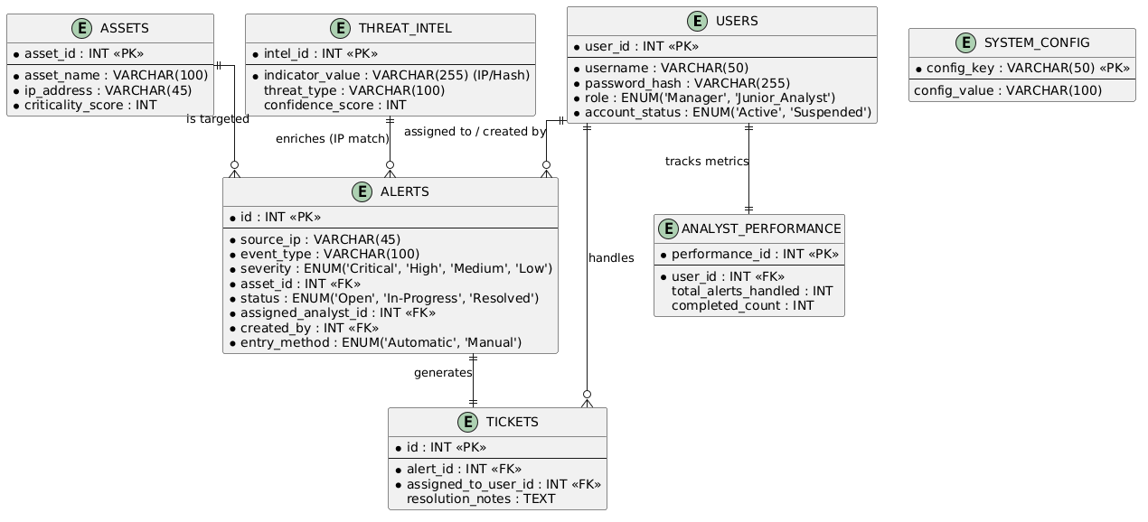

Business Use Case: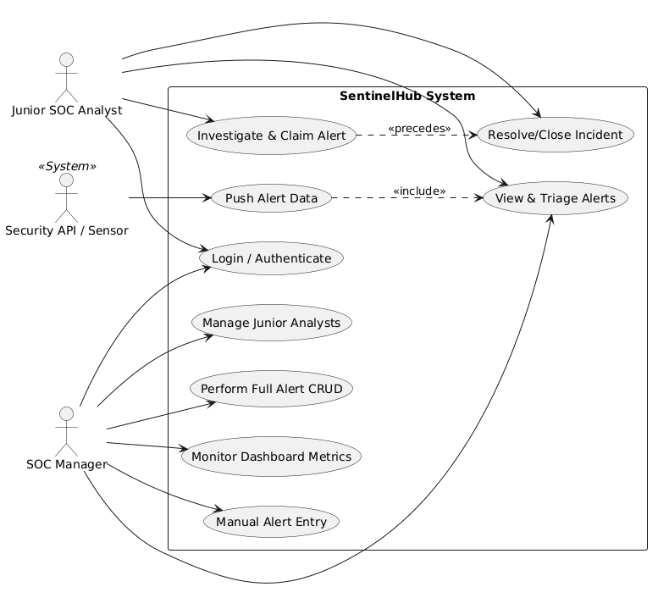

Summary of Project Scope
"SentinelHub is a full-stack Security Operations platform designed to bridge the gap between automated detection and human response. By integrating Python-based automation with a React-driven dashboard, the project streamlines the lifecycle of a security incident—from the moment a threat is ingested to its final containment and resolution."

Future Scope: Containment & SOAR

1. AI-Driven Autonomous SOAR
Currently, your SOAR logic follows predefined rules (e.g., "If Critical, then notify"). The future scope involves integrating Machine Learning to enable autonomous decision-making.
- Predictive Response: Using historical data to predict the likely next step of an attacker and pre-emptively closing those vulnerabilities.
- Self-Healing Networks: Automatically reconfiguring network segments to isolate infected areas without human intervention, reducing Response Time (MTTR) to near zero.

2. Adaptive Micro-Containment
Moving beyond simple IP blocking, future containment will focus on high-granularity isolation.
- Process-Level Isolation: Instead of shutting down a whole server, the system will identify and kill only the specific malicious process or "fork" being used by the attacker.
- Container Sandboxing: Automatically moving a suspicious Docker container into an "Isolated Sandbox" where its activity can be recorded for forensic analysis without it being able to reach the production network.

3. Low-Code/No-Code Playbook Builders
To make the system accessible to non-programmers, the future version of SentinelHub could include a visual interface for building playbooks.
- Drag-and-Drop Workflow: Allowing SOC Managers to create complex logic chains (e.g., "Scan with VirusTotal -> If Malicious -> Block IP -> Reset Password") via a GUI rather than Python scripts.

